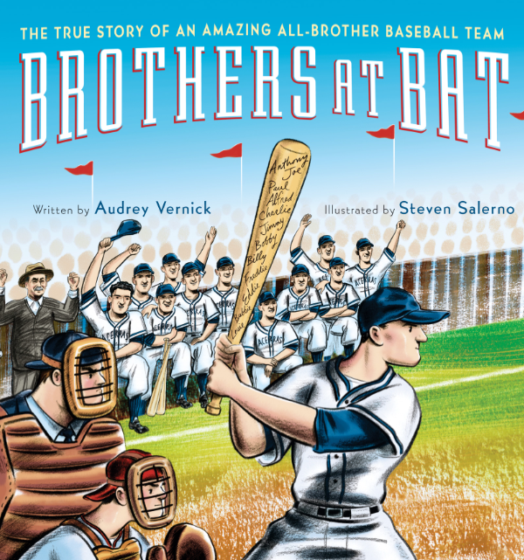

Book Summary
The Acerra family had sixteen children, including twelve ball-playing boys. It was the 1930s and many families had lots of kids, but only one had enough to field a baseball team . . . with three on the bench! The Acerras were the longest playing all-brother team in baseball history. They loved the game, but more important, they cared for and supported each other and stayed together as a team. Nothing life threw their way could stop them. Full of action, drama, and excitement, this never-before-told true story is vividly brought to life by Audrey Vernick’s expert storytelling and Steven Salerno’s stunning vintage-style art.
“Brothers at Bat is a story any baseball fan will enjoy and one that we all should know.”
~ Hall of Famer Cal Ripken, Jr.

pre-reading Prompts
• What kinds of games do you like to play with your family? Which sportsmanship rules does your family follow?
• What is your favorite sport? Who are some of the most famous athletes who play this sport?
• Look at the photo on the Author’s and Artist’s Notes page. What kind of team is this? Where was this photo taken? Is this a recent photo or one from many years ago? How do you know?
• Find New Jersey, New York, Connecticut, the Atlantic Ocean, and Europe on a map. As you read the story, place stickers on the map to keep track of the places the Acerra brothers go.

Discussion questions
• Which season was the Acerra brothers’ favorite? Why?
• Why didn’t the Acerra sisters play baseball?
• Which characteristics made Anthony, Charlie, and Jimmy unique in their family? Which characteristics would your family say make you unique?
• How did Alfred get the courage to play baseball again? • When six of the Acerra brothers were in Europe during the war, what did they miss most about home? What would you miss most?
• Why were the Acerra brothers honored by the Baseball Hall of Fame?
• How did the Acerra family react when their bus broke down on the way home from the Baseball Hall of Fame? How does this reflect their family values?

Post-Reading Activities
• Look at the illustration on page twenty-six of one of the Acerra brothers in uniform holding a letter. What do you think the letter says? Do you think it came from home, or is it a letter that he wrote to someone? Write the letter that you think he is holding. Compare your version to those written by other classmates.
• On page thirty-six, read about the items that Jimmy’s son donated to the Baseball Hall of Fame. Create your own museum display of items to honor your favorite athlete or hero.

•  In 1939, the Acerra brothers boarded a plane for the first time and flew over Newark, New Jersey. Use Google Maps to “fly” over Newark today. What land features do you see that the Acerra brothers would have seen?
•  Take a look at some early baseball cards from the sites listed in the Resources section of this guide. Design a “baseball” card for each of your family members (and one for yourself!) that showcases something each person does well.
•  One sound that the Acerra brothers loved was the slap, slap, slapping of their screen door as they rushed outside in the spring to play baseball. Brainstorm a list of sounds you look forward to hearing each season of the year. Write a poem that highlights your examples of onomatopoeia.
•  How are baseball stats calculated? Visit www.baseball-almanac.com/stats6.shtml
to find out. Play a game of kickball or softball and calculate the stats for either individual students or the whole class. Each time a game is played throughout the year, update and graph the numbers. How do your stats compare over time?
•  Jimmy Acerra used to throw a knuckleball that was hard to hit or catch. Research the physics behind how knuckleballs work and why they’re so tricky, then give it a try on the field! (Younger children can use a tennis ball to practice.)
•  Take a look at the headlines on pages twenty-eight and thirty-five. Choose a scene from the story and write a headline and article to go along with it. Add an illustration with a caption. Display students’ front pages under a banner that reads:
Brothers At Bat: We Read All About It!

Resources
•  Baseball Hall of Fame www.baseballhall.org
•  Library of Congress American Memory Early Baseball Card Collection www.memory.loc.gov/ammem/bbhtml/bbhome.html
•  Smithsonian Institution Baseball Card Collection www.collections.si.edu
(search term: baseball cards)

About the Author
Audrey Vernick is the author of the picture books Is Your Buffalo Ready for Kindergarten? and She Loved Baseball, as well as the middle grade novel Water Balloon. She has published short stories for adults and twice received the New Jersey State Council of the Arts’ fiction fellowship. She lives with her family in New Jersey. Visit her at www.audreyvernick.com.

About the Illustrator
Steven Salerno has illustrated many popular picture books for children, including The Dirty Little Boy by Margaret Wise Brown, Bebe Goes Shopping and Bebe Goes to the Beach by Susan Middleton Elya, as well as his own Little Tumbo, and Coco the Carrot. A graduate of Parsons School of Design, where he studied under famed author/illustrator Maurice Sendak, Steven’s illustrations appear in magazines, advertising campaigns, product packaging, and retail interiors. He lives and works in New York City. Visit him at www.stevensalerno.com.

Discussion and Classroom Activity Guide created by
Natalie Dias Lorenzi.

